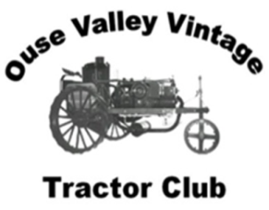
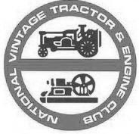

The Ouse Valley Group of
The National Vintage Tractor and Engine Club

Membership 2019
Dear valued member
2019 is sure to be packed with meetings, road runs, BBQ’s and other events.

Please tick required membership.

Membership runs Jan 1st to Dec 31st
Full Membership | £15.00 |  | Name
Joint Membership | £17.00 |  | Address
Senior Citizen | £14.00
Individual Junior | £14.00
Family Membership | £19.00 |  | Postcode
Donation | £ |  | E-mail
Remittance Enclosed |  |  | Tel no.

TVO Licence Required □ Please Tick

Please make cheque payable to : Ouse Valley Group of NVTEC

Please return this Form, Remittance and STAMPED ADDRESSED ENVELOPE to:

Gary Rainbow
18 Churchill Way
Shefford
Bedfordshire
SG17 5UG

I agree to abide by NVTEC Club rules……………………………………… Please sign.
Note: Details will be stored electronically for club use only

PLEASE ALSO RETURN GDPR ACCEPTENCE. This is only required once from each member.

