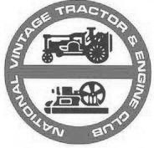
The Ouse Valley Group of
The National Vintage Tractor and Engine Club
Membership Renewal Form 2014
Membership runs Jan 1st to Dec 31st Please Use Block Capitals
Full Membership | £14.50 |  | Name
Joint Membership | £16.50 |  | Address
Senior Citizen | £13.50
Individual Junior | £13.50
Family Membership | £18.50 |  | Postcode
Donation |  |  | E-mail
Remittance Enclosed |  |  | Tel no.
Please return this Form, Remittance and an SAE to: Clive Woodcraft
73 High Street
Please make cheques payable to: Ouse Valley Group of NVTEC Broom
Bedfordshire
I agree to abide by NVTEC Club rules……………………………… SG18 9NA
Note: Details will be stored electronically for club use only Tel : 01767 600817

