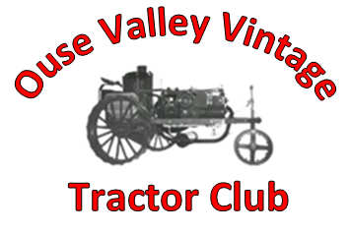
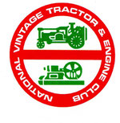

The Ouse Valley Group of
The National Vintage Tractor and Engine Club

Membership 2024
Dear Valued member
2024 is sure to be packed with meetings, road runs, BBQ’s and other events.

Please tick required membership.

Membership runs Jan 1st to Dec 31st
Full Membership | £16.00 | Name
Joint Membership | £18.00 | Address
Senior Citizen | £15.00
Individual Junior | £15.00
Family Membership | £20.00 | Postcode
Donation | £ | E-mail
Remittance  Enclosed |  | Tel no.

TVO Licence Required □ Please Tick

Please make cheque payable to : NVTEC Ouse Valley Group
Bank Transfer to Sort code. 20-41-12, Account No. 30818895. Barclays Bank

Please return this Form, Remittance and STAMPED ADDRESSED ENVELOPE to:

Gary Rainbow
18 Churchill Way
Shefford
Bedfordshire
SG17 5UG

I agree to abide by NVTEC Club rules……………………………………… Please sign.
By signing this form I agree to clubs Data protection rules, available online.
Note: Details will be stored electronically for club use only

